- Problem Description
Consider a manufacturing industry producing components for various automotive manufactures.
Manufacturing industry, from the unit view, can broadly be divided into three main categories namely
- Transmission Line,
- Engine line and
- Component Section.
Thus for operations overview for only Transmission line was considered. Further, the starting point from which material enters the line is Soft cell. Majority of the parts travels through Heat treatment, Sleeve cell and hard cell only after passing from Soft cell. Thus on transmission line, focus will be more on soft cell
Figure 1: Overview
A cellular layout is used at the shop floor. Each of the cells produces a job family consisting of multiple job types.
Each job type has certain demand. Demand for each month varies. Let us consider, a representative cell called ‘SL’ which processes 11 different jobs: J₁, J₂…, J₁₁.
These jobs undergo 49 machining operations. These operations are carried out on 23 non-identical machines (M₁, M_{2,} … , M₂₃).
The process flow for each job is predefined by the process engineers and is shown in Table 1.
For example, the first operation of job 1 (i.e., O₁) is scheduled on machine M_{1,} the second operation (i.e., O₂) is scheduled on machine M₃ and the third operation (i.e., O₃) is scheduled on machine M₆. Thus, job 1 (i.e., J₁) is processed from machine M₁, M₃ and M₆ only. Similarly, the flow of all the jobs in different machines can be read from Table 1.

Table 1 Process flow of jobs
O_{x}/J_{i} | O₁ | O₂ | O₃ | O₄ | O₅ | O₆ | O₇ | O₈ | O₉
J₁ | M₁ | M₃ | M₆ | - | - | - | - | - | -
J₂ | M₁ | M₃ | M₆ | - | - | - | - | - | -
J₃ | M₁ | M₃ | M₅ | - | - | - | - | - | -
J₄ | M₁ | M₃ | M₅ | - | - | - | - | - | -
J₅ | M₁₄ | M₃ | M₅ | - | - | - | - | - | -
J₆ | M₁₄ | M₁₃ | M₁₈ | - | - | - | - | - | -
J₇ | M₁₄ | M₆ | - | - | - | - | - | - | -
J₈ | M₄ | M₁₄ | M₂₃ | M₅ | - | - | - | - | -
J₉ | M₇ | M₈ | M₉ | M₁₂ | M₂₁ | M₂₂ | M₁₇ | M₁₀ | M₁₉
J₁₀ | M₄ | M₂₀ | M₁₃ | M₂₂ | M₁₈ | M₁₉ | - | - | -
J₁₁ | M₉ | M₂ | M₁₆ | M₁₁ | M₁₃ | M₁₅ | M₁₈ | M₁₉ | -

One example process flow for job J₉ is as described in figure 2. The sequence of these jobs on various machines and their batch-sizes are currently decided by production manager and supervisors based on their experience. The initial batch size and initial sequence of jobs in the respective machine for each operation are presented in Table 2. Also, in Table 2, jobs properties i.e. processing times $(PT)$ setup times$(ST)$, are offered.

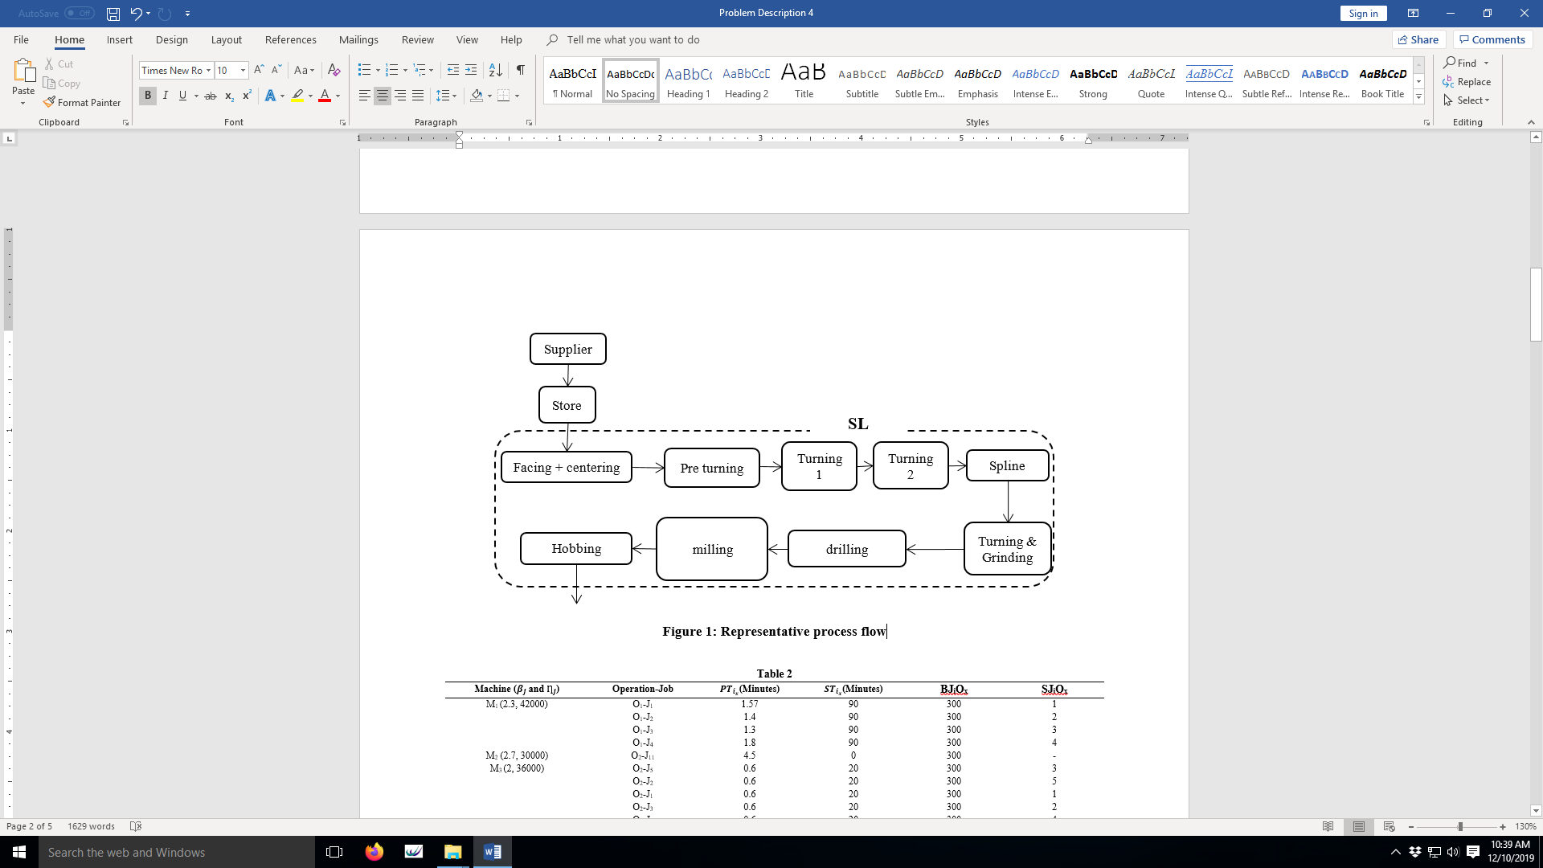
Figure 2: Representative process flow of job J9
To summarize following are the problem specifications:
- No. of machine: 23
- No of job types: 11
- Total number of operations: 49
- Initial demand: 3000 for each job type
- Planning horizon one month (i.e. 43200 minutes)
- Machine characteristics:
  - Processing time for each job
  - Setup time for changeover of job
  - Failure distribution and repair distribution
  - Each machine is equipped with buffers. The buffers hold raw material or work in process or semi-finished or finished items.
The production of jobs depends on the availability of machines. The time to failures of the machines follow a two-parameter Weibull distribution. Shape parameter $β_{j}$ and scale parameter$Ƞ_{j}$ of these distributions are shown in Table 2. Repair time is not constant and is distributed according to lognormal distribution for each machine with lognormal (1800 minutes, 600 minutes).

Machine ($β_{j}$and $Ƞ_{j} (in mibutes)$) | Operation-Job | $PT$(Minutes) | $ST$(Minutes) | Batch Size of each job | Sequence Number
M₁ (2.3, 42000) | O₁-J₁ | 1.57 | 90 | 300 | 1
 | O₁-J₂ | 1.4 | 90 | 300 | 2
 | O₁-J₃ | 1.3 | 90 | 300 | 4
 | O₁-J₄ | 1.8 | 90 | 300 | 3
M₂ (2.7, 30000) | O₂-J₁₁ | 4.5 | 0 | 300 | -
M₃ (2, 36000) | O₂-J₅ | 0.6 | 20 | 300 | 1
 | O₂-J₂ | 0.6 | 20 | 300 | 2
 | O₂-J₁ | 0.6 | 20 | 300 | 4
 | O₂-J₃ | 0.6 | 20 | 300 | 3
 | O₂-J₄ | 0.6 | 20 | 300 | 5
M₄ (2, 48000) | O₁-J₁₀ | 1.6 | 90 | 300 | 2
 | O₁-J₈ | 1.8 | 420 | 300 | 1
M₅ (3, 32400) | O₃-J₃ | 1.1 | 60 | 300 | 1
 | O₃-J₄ | 1.24 | 60 | 300 | 3
 | O₃-J₅ | 1.1 | 60 | 300 | 4
 | O₄-J₈ | 1.1 | 60 | 300 | 2
M₆ (2.6, 25200) | O₃-J₁ | 1.8 | 60 | 300 | 2
 | O₂-J₇ | 1.9 | 60 | 300 | 3
 | O₃-J₂ | 2.1 | 60 | 300 | 1
M₇ (2.6, 28800) | O₁-J₉ | 7.6 | 60 | 300 | -
M₈ (1.9, 33000) | O₂-J₉ | 8 | 60 | 300 | -
M₉ (2, 48000) | O₃-J₉ | 2.9 | 60 | 300 | 2
 | O₁-J₁₁ | 1.2 | 30 | 300 | 1
M₁₀ (2.4, 42000) | O₈-J₉ | 2.66 | 0 | 300 | -
M₁₁ (2.3, 30000) | O₄-J₁₁ | 8.1 | 0 | 300 | -
M₁₂ (2.9, 37200) | O₄-J₉ | 2.23 | 0 | 300 | -
M₁₃ (1.8, 27600) | O₅-J₁₁ | 1.2 | 60 | 300 | 1
 | O₃-J₁₀ | 0.6 | 30 | 300 | 3
 | O₂-J₆ | 0.6 | 30 | 300 | 2
M₁₄ (1.3, 27000) | O₁-J₅ | 1.3 | 90 | 300 | 1
 | O₁-J₆ | 1.4 | 90 | 300 | 4
 | O₂-J₈ | 1.5 | 90 | 300 | 2
 | O₁-J₇ | 2.3 | 90 | 300 | 3
M₁₅ (2, 48000) | O₆-J₁₁ | 4.3 | 180 | 300 | -
M₁₆ (2.6, 42000) | O₃-J₁₁ | 10.6 | 60 | 300 | -
M₁₇ (2.1, 51000) | O₇-J₉ | 1.86 | 45 | 300 | -
M₁₈ (2.5, 42000) | O₇-J₁₁ | 1.4 | 60 | 300 | 3
 | O₅-J₁₀ | 1.3 | 60 | 300 | 1
 | O₃-J₆ | 1.4 | 60 | 300 | 2
M₁₉ (2.4, 30000) | O₉-J₉ | 0.56 | 90 | 300 | 1
 | O₈-J₁₁ | 0.56 | 90 | 300 | 2
 | O₆-J₁₀ | 0.6 | 90 | 300 | 3
M₂₀ (2.3, 36000) | O₂-J₁₀ | 7 | 180 | 300 | -
M₂₁ (1.5, 22800) | O₅-J₉ | 1.2 | 30 | 300 | -
M₂₂ (1.2, 24000) | O₆-J₉ | 1.3 | 45 | 300 | 2
 | O₄-J₁₀ | 1.6 | 45 | 300 | 1
M₂₃ (2.7, 36000) | O₃-J₈ | 2.12 | 0 | 300 | -
An optimized job sequence of production is important for timely completion and fulfilling the demand of components.
The jobs are processed in batches having several items in a batch. Batch-sizing is another key decision, as batches having large size will reduce the number of setups but will increase the WIP inventory level.
Identification and optimization of right decision variables is critical. Few of the decision variables are described below:
Sequence:
There are many possible sequences for processing. For example, there are four jobs to be processed on M1. They can be sequenced in 24 different ways. Similarly, M3 processes five jobs so there are 120 possible ways to prepare sequences for M3. Both M1 and M3 together would form 2880 of permutations. When combined for all the machines together billions ${ (1.72×10}^{10})$ of possible permutations emerge.
Batch size:
Jobs are processed in batches. One-time setup would be required to process a batch. But larger batch may create undesired idle time. So, an optimum batch size would be required such that throughput is maximum.
Preventive maintenance:
Machines are subject to failures. After certain cycles of the machine use, it may fail more frequently. Some machine may fail more frequently than other machines. Optimizing preventative maintenance schedule these machines is another important decision on any shop floor.
Other decisions like inventory level, resource optimization, capacity decision etc. are also involved in any such shop floor.
The above industrial case is a good example to showcase the value of simulation modelling in understanding the shop floor dynamics and identifying bottlenecks.

- Modelling and Simulation
Model the industrial scenario mentioned above in problem description on Tecnomatix Plant Simulation platform.
The model is built by bringing in machines, jobs and buffer on platform. Jobs are detailed with job characteristics. Machines are detailed with machine characteristics. The right flow of each job is given such that all jobs take right path as described by manufacturing scenario. Following figure gives complete overview of the model.

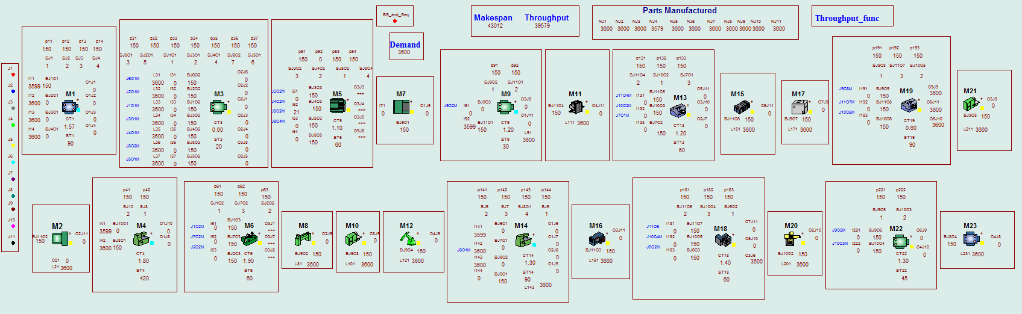
Figure 3: Overview of the model (Representation)

